Norden Club Christmas Dinner Highlights/Photos
The Christmas Dinner was held on Saturday, December 2, at First Lutheran Church in Lincoln. The featured country was “Festive Finland”. Everyone seemed to have a great time and we look forward to next year. Here are some pictures of the room set up ready for the guests to arrive.
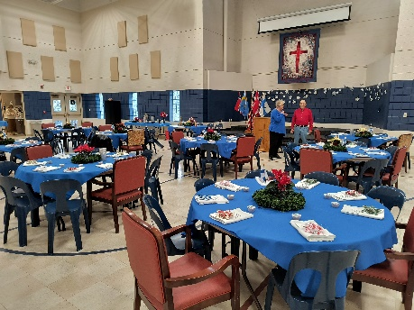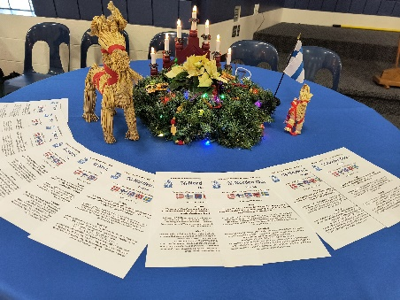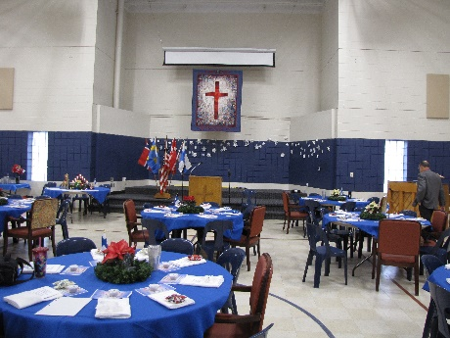
After appetizers we enjoyed dinner, in preparation for the program.
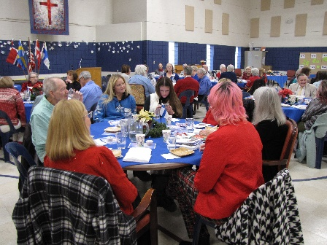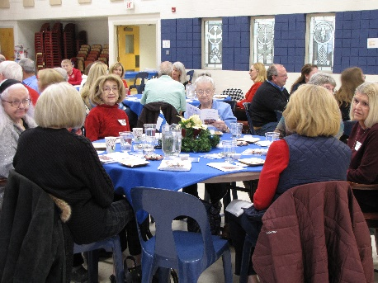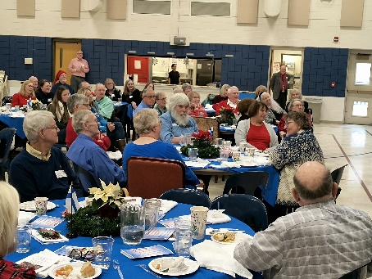
Entertainment was provided by the County Four from the Lincoln Continentals. Ted Ericson made a presentation regarding our featured Country, Finland. We then finished with singing led by Kendra Hartwig and Kristina Hanson.
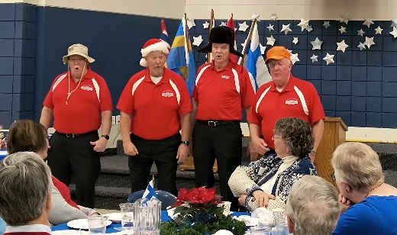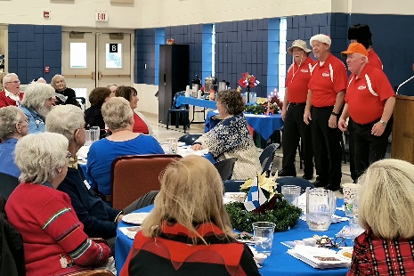
Below are some pictures of the Silent Auction that benefited the Norden Club Foundation.
